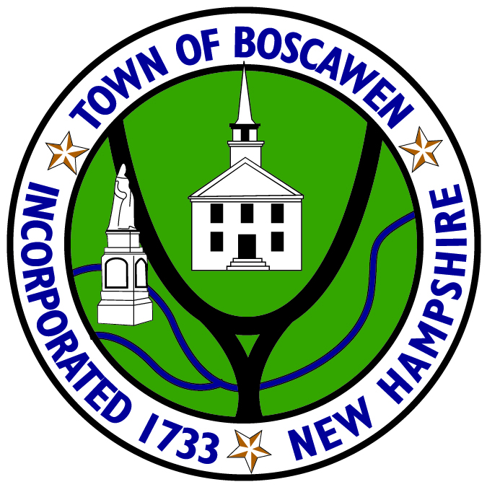

Zoning Board of Adjustment

Members

Dr. Gail Devoid, PhD
Chair

Doug Supry
Vice-Chair

Tracy Jo Bartlett
Member

Ann Dominguez
Member

Scott Maltzie
Member

Edward J. Cherian, Jr
Member Ex-Officio

Alternate Members

Tama Tillman
Alternate Member

Planning & Community Development Staff

Kellee Jo Easler
Planning & Community
Development Director

Kearsten O’Brien
Planning & Community
Development Assistant

Crystal Tuttle
Planning & Community
Development Clerk

Mya Balch
Planning & Community
Development Office Clerk

Rose Fife
Recording Secretary

Town of Boscawen
116 North Main Street, Boscawen, NH 03303 | Telephone: 603.753.9188 | Fax: 603.753.9183

AGENDA
Zoning Board of Adjustment
April 27, 2021 @ 7 pm

No meeting scheduled due to no appeals.

Please check the website @ www.townofboscawen.org or the Planning & Community Development office for any recent updates, prior to the meeting.

