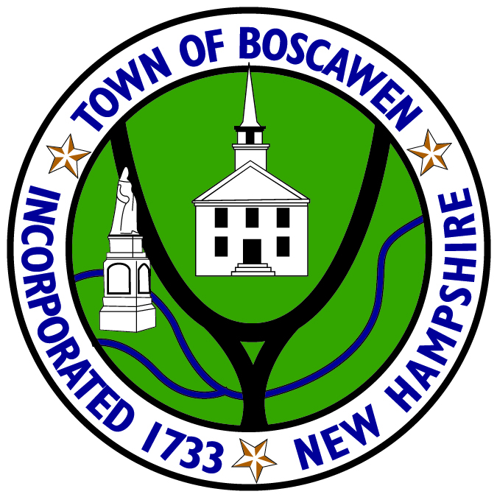

Old Home Day Committee
Members

Polly Dawson
President

Rhoda Bergeron
Member

Lyman Cousens
Member

Susan Kilgus
Member

Kim Kenney
Member

Laura Lane
Member

Beverly Lacoy
Member

Lori Bernard
Member

Lorrie Carey
Ex-Officio

Danielle Bosco
Recording Secretary

Town of Boscawen
116 North Main Street, Boscawen, NH 03303 | Telephone: 603.753.9188 | Fax: 603.753.9183

Agenda
March 16, 2020 at 6:00pm
Municipal Office Building
4th Floor Meeting Room

The Old Home Day Committee Meeting scheduled for March 16, 2020 has been canceled.

Next Meeting:
April 20, 2020 at 6:30pm

